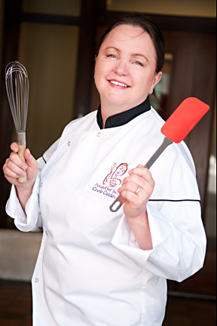
Author Bio
Photo by Ingrid Pape-Sheldon
Carole Cancler has a background in food science, product development, software applications, and technical writing. As a chef, Carole owned and operated Private Chef Natural Gourmet in Seattle, Washington, for 14 years. Her company made custom frozen gourmet meals. Prior to that, Carole spent 11 years at Microsoft as a test engineer and program manager.
Currently, she focuses on consulting and writing for the food and technology industries. Her first book, The Home Preserving Bible describes the techniques for eight essential methods to preserve foods, and provides over 300 recipes. Find more articles and recipes from Carole online at homepreservingbible.com, examiner.com/user-caroleca, and livingonthecheap.com. She also teaches cooking classes—among them canning and preserving, where students learn firsthand the best ways to can, freeze, and dry seasonal fruits and vegetables. In her spare time, Carole volunteers at local farmers markets in Seattle.
Carole has enjoyed a lifelong love affair with cooking. Her Midwestern mother and Slovenian grandmother instilled in her a love of good food. In 1990, she began traveling internationally, most often to attend cooking schools, explore food markets, and taste the cuisines of the places she visits. She has traveled by jet, train, and ship to over 20 countries, including Portugal, Italy, Croatia, Turkey, Japan, and Thailand. Still on her list of places to see (but not limited to!) are India, Greece, Argentina, and Tahiti.
A Seattle native, Carole holds a Bachelor of Science degree in Food Science and Nutrition from the University of Washington. She also studied at several culinary schools in France, including Le Cordon Bleu in Paris. She loves studying about the anthropology of food—particularly how indigenous foods have traveled and been integrated throughout the world. In addition to her experience as a professional in the food industry, Chef Carole has decades of practice in home canning and preserving.
The Home Preserving Bible by Carole Cancler, New York: Alpha Books, 2012, Paperback, 464 pages, ISBN-13: 978-1615641925 is available nationwide beginning September 4, 21012 from booksellers and canning supply retailers with a suggested retail price of $21.
###
CONTACT: Carole M. Cancler, 206-999-7292, Carole@CaroleCancler.com

